***Dt : 25/8/2022***

***Execution flow of above program:***

***ClassFiles:***

***UserDetails.class***

***UserRegistration.class***

***DisplayUserDetails.class***

***DemoMethods10.class***

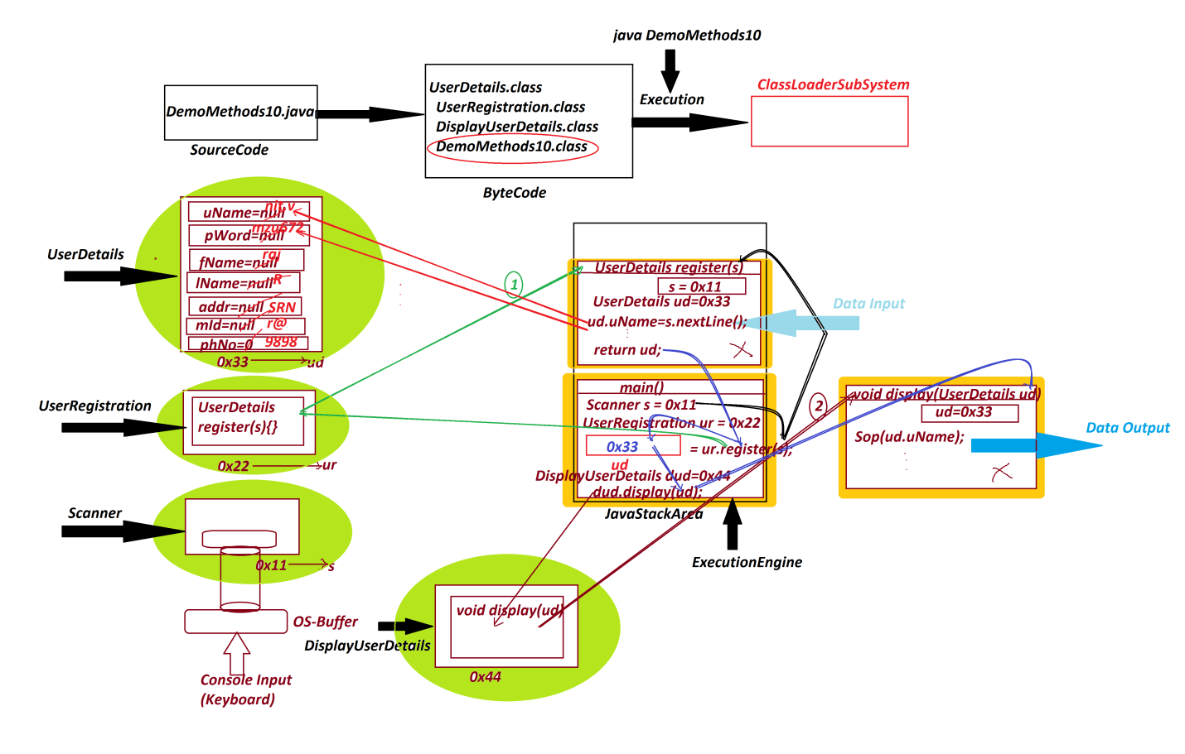

***========================================================***

***Note:***

***=>when we pass Non-Primitive datatype Variables as parameters,***

***then Object references are moved from one method to another***

***method.***

***========================================================***

***Assignment:***

***wap to read and display Customer details using reference***

***variables as parameters?***

***Layout:***

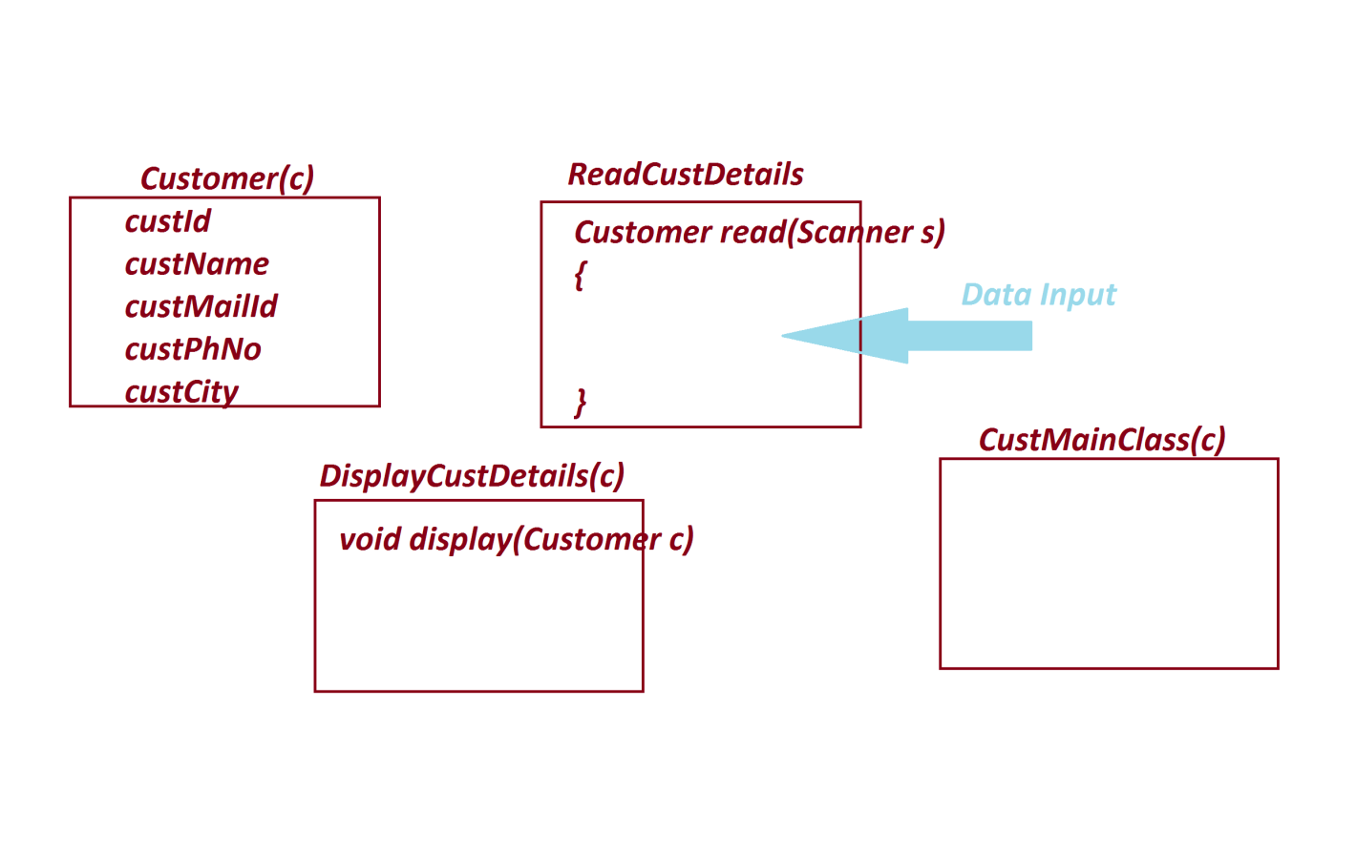

***========================================================***

***\*imp***

***Blocks in Java:***

***=>The set-of-statements which are declared within the flower***

***brackets and executed automatically is known as block.***

***=>Blocks in Java are categorized into two types:***

***1.Static blocks***

***2.Non-Static blocks or Instance blocks***

***1.Static blocks:***

***=>The blocks which are declared with 'static' keyword are***

***known as static blocks or Class blocks.***

***syntax:***

***static***

***{***

***//set-of-statements***

***}***

***Behaviour:***

***=>These static blocks are executed only once when the class is***

***used for the first time.***

***=>static blocks will have highest priority in execution than***

***static methods.***

***=>These Static blocks can access static variables directly,***

***but cannot access Instance variables.***

***Ex : DemoBlock1.java***

***class DemoBlock1 //MainClass***

***{***

***static int a=10;***

***public static void main(String[] args)***

***{***

***System.out.println("====main()====");***

***System.out.println("The value a:"+a);***

***}***

***static***

***{***

***System.out.println("====MainClass static block====");***

***System.out.println("The value a:"+a);***

***}***

***}***

***o/p:***

***====MainClass static block====***

***The value a:10***

***====main()====***

***The value a:10***

***========================================================***